ABSTRACT
Iris recognition is the process of recognizing a person by analyzing the apparent pattern of his or her iris. There is a strong scientific demand for the proliferation of systems, concepts and algorithms for iris recognition and identification. This is mostly because of the comparatively short time that iris recognition systems have been around. In comparison to face, fingerprint and other biometric traits there is still a great need for substantial mathematical and computer-vision research and insight into iris recognition. One evidence for this is the total lack of publicly available adequate datasets of iris images.
The program converts a photo of an eye to an 'unrolled' depiction of the subject's iris and matches the eye to the agent's memory. If a match is found, it outputs a best match. The current functionality matches that proposed in the original requirements.

INTRODUCTION

Introduction:
Iris recognition is the most powerful biometric technology there is. Nothing else comes close. Nothing.
- Most accurate
- Scalable
- Opt-in
- Non-contact
- Interoperable cameras
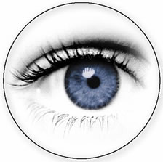

What is the Iris:
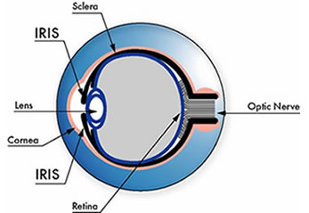
The iris is the plainly visible, colored ring that surrounds the pupil. It is a muscular structure that controls the amount of light entering the eye, with intricate details that can be measured, such as striations, pits, and furrows. The iris is not to be confused with the retina, which lines the inside of the back of the eye.
No two irises are alike. There is no detailed correlation between the iris patterns of even identical twins, or the right and left eye of an individual. The amount of information that can be measured in a single iris is much greater than fingerprints, and the accuracy is greater than DNA.

Taking a Picture:

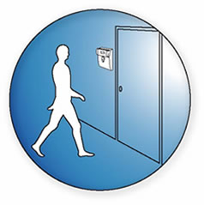

An iris recognition camera takes a black and white picture from 5 to 24 inches away, depending on the type of camera. The camera uses non-invasive, near-infrared illumination (similar to a TV remote control) that is barely visible and very safe. Proof Positive certified cameras are in compliance with all applicable international illumination safety standards, including ANSI/IESNA RP-27.1-96 and IEC 60825-1 Amend.2, Class 1 LED. These are the latest worldwide standards.
Unlike other biometric technologies that can be used in surveillance mode, iris recognition is an opt-in technology. In order to use the technology you must first glance at a camera. Iris recognition cannot take place without your permission.

Iris Recognition:
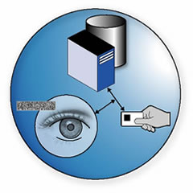
In less than a few seconds, even on a database of millions of records, the IrisCode template generated from a live image is compared to previously enrolled ones to see if it matches any of them. The decision threshold is automatically adjusted for the size of the search database to ensure that no false matches occur even when huge numbers of IrisCode templates are being compared with the live one.
Some of the bits in an IrisCode template signify if some data is corrupted (for example by reflections, or contact lens boundaries), so that it does not influence the process, and only valid data is compared. Decision thresholds take account of the amount of visible iris data, and the matching operation compensates for any tilt of the iris.
A key advantage of iris recognition is its ability to perform identification using a one-to-all search of a database, with no limitation on the number of IrisCode records and no requirement for a user first to claim an identity, for example with a card.

Requirements :
Correctly identify the iris in the given photograph.
Correctly match the subject to a known identity.
Determine the subject's existence in the database within 10 seconds.
Must be able to properly identify a mismatched subject on a subsequent attempt.

8 Stages of Iris Detection:
Stage 1: Scan Eye
The eye scanning will be simulated in this system as we have no method of taking real-time images of subjects. Therefore, all eye images are to be jpeg image files at least 1000 x 1000 pixels in dimension.

The eye is scanned by manually selecting the file and instructing the agent to scan it. The agent begins scanning an eye by turning the jpeg file into an image object in full color (24 bit RGB).
Stage 2: Eye Grayscaling Algorithm
The agent next converts the full-color image to an 8-bit representation. This reduces space complexity, making further computations faster without losing reliability.
Stage 3: Median Filter
Applies a median filter to the grayscaled image to reduce the amount of noise and artifacts before the pupil center detection.
Stage 4: Pupil Center Detection
To perform the fifth step, the agent must now find the center of the pupil to orient the coordinate system at the center of the eye.
Stage 5: Canny Edge Detection
Step 5 also requires that the edges of the iris and pupil be marked so an edge detection process needs to be completed by the agent. We decided to have the agent use the 'Canny Edge Detection' algorithm.
Stage 6: Pupil And Iris Radius Detection Algorithm
In this stage the agent attempts to find the radius of both the pupil and iris using the center found in stage 3 and the edges found in stage 4. The radii will be used by the agent in both step 6 and 7.

Stage 7: Iris Localization
This process is mostly for visual purposes and refers to removing erroneous information from the original image outside of the iris radius, whereby leaving only the image within the bounds of the iris radius intact.
Stage 8: Iris Unrolling Algorithm
The agent must now use the radii found in stage 5 as well as the pupil center found in stage 3 to perform the unrolling of the iris. Traversing the eye in a polar coordinate, circular fashion, the agent maps information from the original image to the output (unwrapped) image.
Stage 9: Iris Matching
Scans the eye to be matched using the previous 8 steps.
- Iterates over each of the identies in the memory and performs the following steps
- Performs a mean filer on the unrolled image stored in memory
- Subtracts the mean filtered image from the unwrapped image of the eye being matched to
- Computes a percentage difference between the eye being matched and the identity
- Selects the identity that has the highest percentage match and displays the result to the user in a dialog box

SYSTEM ANALYSIS

Software Requirements Specification

The first step in developing anything is to state the requirements. This applies just as much to leading edge research as to simple programs and to personal programs, as well as to large team efforts. Being vague about your objective only postpones decisions to a later stage where changes are much more costly.
The problem statement should state what is to be done and not how it is to be done. It should be a statement of needs, not a proposal for a solution. A user manual for the desired system is a good problem statement. The requestor should indicate which features are mandatory and which are optional, to avoid overly constraining design decisions. The requestor should avoid describing system internals, as this restricts implementation flexibility. Performance specifications and protocols for interaction with external systems are legitimate requirements. Software engineering standards, such as modular construction, design for testability, and provision for future extensions, are also proper.
The analyst must separate the true requirements from design and implementation decisions disguised as requirements. The analyst should challenge such pseudo requirements, as they restrict flexibility. There may be politics or organizational reasons for the pseudo requirements, but at least the analyst should recognize that these externally imposed design decisions are not essential features of the problem domain.

Requirements:

Software Used : JDK 1.5 / Java Swing

Hardware Used : Pentium IV, 128 MB of RAM, clock speed 900 MHz.

SYSTEM DESIGN

System Design

During analysis, the focus is on what needs to be done, independent of how it is done. During design, decisions are made about how the problem will be solved, first at high level, then at increasingly detailed levels.
System design is the first design stage in which the basic approach to solving the problem is selected. During system design, the overall structure and style are decided. The system architecture is the overall organization of the system into components called subsystems. The architecture provides the context in which more detailed decisions are made in later design stages. By making high level decisions that apply to the entire system, the system designer partitions the problem into subsystems so that further work can be done by several designers working independently on different subsystems.
The system designer must make the following decisions:
- Organize the system into subsystems.
- Identify the concurrency inherent in the problem.
- Allocate subsystems to processors and tasks.
- Choose an approach for management of data stores.
- Handle access to global resources.
- Choose the implementation of control in software.
- Handle boundary conditions.

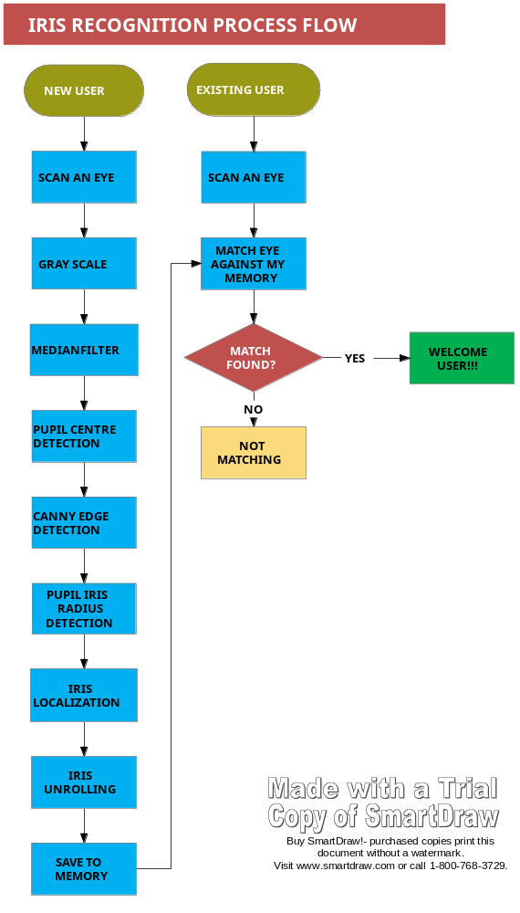

- To design a iris recognition system based on an empirical analysis of the iris image and it is split in several steps using local image properties.

The system steps are

- capturing iris patterns

- determine the location of the iris

- boundaries converting the iris boundary to the stretched polar coordinate system

- extracting the iris code based on texture analysis using wavelet transforms

- Classification of the iris code.

Need for Bio metric system

- Hackers in cryptography

- Biometric data is unique and cannot be transferred

- Extremely difficult to duplicate

Identification vs verification

- Verification (one to one)
Eg password verification

- Identification (One to many)
Eg face recognition

Need for high speed processors to perform computation

Biometric Error

False acceptance

- Authenticates an impostor

False rejection

- Rejected a valid user

Cross over accuracy

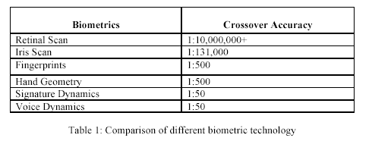

Iris recognition system

- 1. Capturing the image

- 2. Defining the location of the iris

- 3. Optimizing the image

- 4. Storing and comparing the image

Working of a biometric system

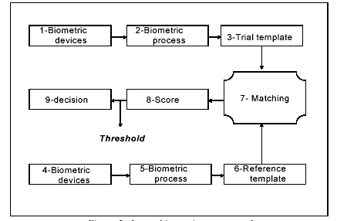

Working of a biometric system

- capture the chosen biometric

- process the biometricand extract and enroll the biometric template

- store the template in a local repository, a

- central repository, or a portable token such as a smart card

- live-scan the chosen biometric

- process the biometric and extract the biometric template

- store the reference template

- match the scanned biometric against stored templates

- provide a matching score to business applications with threshold value

- record a secure audit trail with respect to system

SYSTEM DEVELOPMENT

Following the logical design is physical design. The physical design may also be called as system development. This produces the working system by defining the design specifications that tell programmers exactly what the candidate system must do. In turn, the programmer writes the necessary programs or modifies the software package that accepts input from the user, performs necessary calculations through the existing file or database, produces the report on a hard copy or displays it on screen, and maintains an updated database at all times. In this phase we have done the following activities:
- Hardware & Software specifications.
- Cost estimations.
- Coding

Hardware and Software Specifications
A major element in building systems is selecting compatible hardware and software. The systems analyst has to determine what software package is best for the candidate system and, where software is not an issue, the kind of hardware and peripherals needed for the final conversion. Hardware and software selection begins with requirement analysis, followed by a request for proposal and vendor evaluation. The final system selection initiates contract negotiations.
We consider the following to select hardware and software for development environment:
- Reliability
- Functionality
- Capacity
- Flexibility
- Usability
- Security
- Performance
- Serviceability
- Ownership
- Minimal costs

Hardware:

Processor: 1 GHz
Hard disk: 20 GB
RAM: 128 MB

Software:

Operating System: Windows XP
Application Programming: JDK 1.5 or higher
GUI Programming: Java Swing

Feature Code Generation

The majority of researchers have proposed wavelets approaches in order to capture local iris features at different scales. In our case, we have adopted the method introduced in [19].
After the iris image segmentation process is completed, the iris code is performed using Haarwavelet packets as well as the energy of the packets sub-images to extract texture phase structure information of the iris and to compute the iris 64-bits codes. Figure2. Wavelet packets decomposition for iris image The Iris code generation process can be summarized in the following steps:

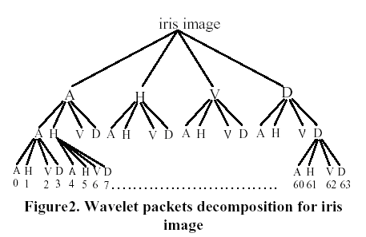

1. Wavelet packets decomposition: We have used the Haar wavelet in a 3-level wavelet packet decomposition to extract the texture features of the unwrapped images [18]. This generates 64 wavelet packets (output iris sub images), numbered 0 to 63.The images contain approximation (A), horizontal detail (H), vertical detail (V) and diagonal detail (D) coefficients respectively as shown in Figure 2.

2. Wavelet packets energy computation: In order to obtain the most texture information in packet sub images, we have used an energy measure. The
mean energy distribution allows evaluating which packets are used to compute the normalized adapted threshold for our iris code generation. The energy measure i E for a wavelet packet sub image i W can be computed as follows

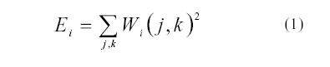

Figure 3(a) plots the mean energy distribution for the 64 wavelet packets subimages shown in Figure 1. This figure shows that energies of the wavelet packets 1 and 49 are the appropriate energies and the most suitable to compute the adapted threshold for iris code generation. However, in Figure 3(b), the energies of the wavelet packets 1 and 3 are the appropriate
energies. On the other hand in [18], the authors have mentioned that the packet 2 and 10 are always used to compute their iriscode but, the most texture information are located in packets (subimages) 1 and 49. This shows that the author’s assumption for the iris image

Signature computation using wavelet packets 2 and 10 is not always true because they have been using the mean energy distribution for the 149 unwrapped images of their iris database. This result has been confirmed by the authors of [21] who have mentioned that the HD distribution for the CASIA database has not been performed yet using the approach [19]. Moreover, Table 1 shows the first four maximal energy values for the 64 sub images for each iris specimen of the Image 088 of CASIA database. Clearly, we have not the same dominant energy for each specimen image iris. Figure 4 shows those packets 2, 49 and 7 holds much energy as well for the
756 CASIA iris images. It is therefore interesting to evaluate also the possibilities of using those packets as appropriate energies to generate iris codes as described in [19].

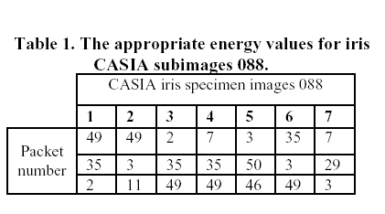

In our approach, we do not adopt the same strategy as that in [19].We use the appropriate wavelet packet energies of each iris image to compute the adapted
threshold to encode the 64 sub images. Let E1…E be the appropriate wavelet packet energies of the packets 1… respectively. We define the normalized adapted threshold S as follows:
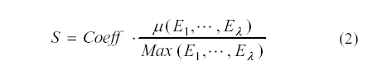

where ( Ei… E) represents the mean wavelet peak energy value, Coeff as a constant and is the number of the appropriate energies. Therefore, the threshold S is not optimized experimentally (S=10) as defined in [19] for all iris images but each iris wavelet decomposition produces the adapted threshold S. For example, from Table 2, we have several adapted thresholds to encode the iris images. So, for
iris 088_1_1, we choose S=1.341 to code the sub images using only the two aximal energies of the packets 1 and 49. But we choose S=1.320 using the three first maximal energies for the packets 1, 49 and 35. However, for another iris image we will not have the same adapted thresholds. In this paper, we have choose
Coeff = 1.4 as a constant.

3. Iris feature coding:

After determination the appropriate wavelet packets energies and the normalized adapted threshold, we can carry out the coding of the 64 wavelet packets energies to generate a compact iriscode by quantizing these energies into one bit according to each appropriate energy. Let E be the
appropriate energy of the peak . Then the iriscode C computed according to E we define by the following:

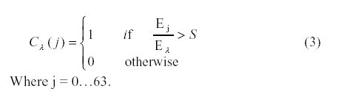

In our approach, we have used significant wavelet
Coefficients of the iris sub image. Each used appropriate energy resulting in a total of 64 bits which correspond to the 64 sub images of the iris wavelet decomposition. Therefore, we obtain one iris code according to each energy. The iris code of the iris 088_1_1 of Fig 2, computed using the three first energy peaks ( = 2...4) is illustrated in Figure 5. We note that our iris coding gives distinct iris codes for each appropriate energy E

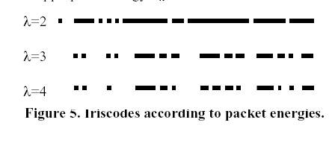

3. Iriscodes matching

The iris codes matching task is performed by pairing the iriscodes extracted from the input and the template iris images. The most common comparison method of iris signatures is the Hamming Distance (HD) [12]. This comparison is to be made with the user’s iris template, which will be calculated depending on the binary matching algorithm which is implemented by the Boolean exclusive-OR operator
( ) applied to the 64 bit vectors that encode any two iris codes.
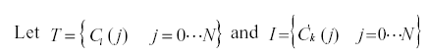

The preceding distance is computed according to the appropriate energy (maximal value) between two iris signatures in order to decide if both come from images of the same iris (authentic distance) or from images of different iris (impostoristance). Therefore, the combination of two or several packets is likely to hold more discriminating information than what each of them does separately as mentioned in. So, the preceding distance can be extended for two appropriate energies of each iris image as follow [18]:
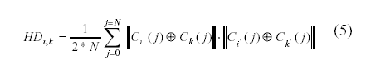

4. Experimental results
In this section, we analyze the performance of the proposed iris verification algorithm. So, to evaluate the performance of our algorithm, different experiments on the Institute of Automation, Chinese Academy of Science, CASIA [20] databases have been carried out. As mentioned in [23,24], automatic detection of the pupils is easier because CASIA database images have a black circle in the pupil and some of these black circles cover the part of iris and also the specular reflection. First, we report the experimental results obtained running our algorithm
using several wavelets categories. Thereafter, we present some result to study the effect of the wavelet packet combination. Finally, we compare our performance with the algorithms reported in [18,19] which use the fixed threshold. For the first experiment, we have uses the first wavelet packet feature that has the maximal energy value to generate the iris signature (to encode 64 bits of the wavelet packets). This experiment was motivated by an iris code computation using only two appropriate energies according to the equation (2 and 3) to compute the adapted threshold and one iris code according to the maximal energy. The energy corresponding to sub image 0 has not been used because this sub image contains offset information.

The discrimination results using wavelet packets categories are shown in Table 2. Clearly, using the first appropriate energy, the Haar wavelets are most suitable for iris recognition. The Receiver Operating Curve (ROC) for results is shown in Figure6 (FAR: False Acceptance Rate and FRR: False Reject Rate).

Thus, our matching algorithm is slower with the error rate EER=2,38%, 4.67%, 4.68%, 5.28% and 6.28% for Biothogonal, Daubechies, Symlet, Coiflet
and Haar wavelets, respectively.

However, the appropriate energies of the packets combination have independently proved to achieve positive separation only for the Haar wavelets compared to the choices of these appropriate energies.

Figure 7 gives the performance results using the dominant energies combination. Obviously, we can see consistent performance improvement of our matching
using the first and the third energies of each iris image decomposition. Hence, using the combination of these appropriate energies for iris code generation, our
matching algorithm is slower with the error rate EER=1.41% using Haar wavelets. The drawn significant result starting from these experiments is that the combination of the wavelet packets for the other wavelets types does not give a better performance for our iris recognition system.
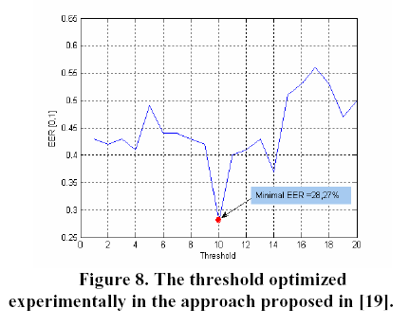

Before comparing our approach with those of [18,19], we illustrate in Figure 8, the minimal ERR curve by varying the threshold S from 1 to 20. With the threshold S=10, we obtain the minimal EER for the CASIA database. Clearly, the matching algorithm [19] achieves better performance for the threshold S=10 using the packets 2 and 49 with EER=28.27%. This confirms the choice of the authors.

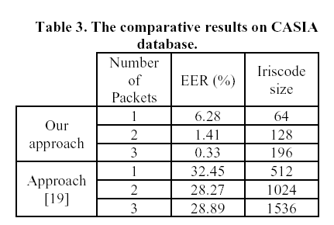
Compared with these approaches, our iris matching achieves better performance using one appropriate energy or the combination of several ones. The comparative results are shown in Table 3 in terms of iris code size and ERR in respect to the database CASIA. Obviously, the experiments conducted over a sample of all CASIA iris image database indicate that the improving matching accuracy is not directly proportional to the combination of the iriscodes generated from the appropriate energies as in the approach [19]. As illustrated in Figure9, we have obtained the error rate EER=1.41%, 3.71% and 4.76% using a single appropriate energy and EER= 3.03%, 1.41% and 5.0% for the combination of the first three appropriate energies, respectively. Figure 9 shows the ROC curves comparison of our approach with the ones proposed in [19] in both these situations. It can be seen that, in all cases, the Equal Error Rate, is always below 5%, achieving 1.05% for the first energy. More importantly a FAR=0.06% has been obtained for very low rates of False Rejection FRR=1.2%, which means that our system is more appropriate for very high security environments.

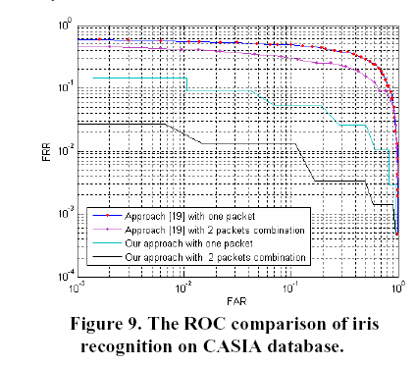

Source Code Samples:

Main Class

package IrisRecog;

/**
* Main.java
*
* Drives the creation of the model-view design and starts the application GUI.
*

*/

public class Main
{
/**
* Main method initiates the model and the desing, relates them together,
* and starts the application GUI.
*
* @param args String array of command line arguments
*/
public static void main(String [] args)
{
GUI gui_View = new GUI();

IrisRecog irg_Model = new IrisRecog(gui_View);

gui_View.setModel(irg_Model);
}
}

Iris Recognition Class File:

package IrisRecog;

/**
* IrisRecog.java
*
* The model portion of the application (in the model-view design) that conducts
* the operations requested by the view (the GUI). This class makes use of many
* of the public static functions available in the Functions class. Logically,
* this class represents the abilities of the agt_Agent and defines the actions it
* is capable of completing.
*

*/

import java.awt.*;
import java.awt.image.*;
import java.util.*;
import java.lang.*;

public class IrisRecog
{
/*
* A reference to the user interface.
*/
protected static GUI gui_UserInterface;

/*
* The agent of the model
*/
protected Agent agt_Agent;

/**
* Creates the model and relates it to the specified user interface.
*
* @param ui The user interface to associated with the model
*/
public IrisRecog(GUI ui)
{
this.gui_UserInterface = ui;
this.agt_Agent = new Agent(ui);
}

/**
* Returns the agent that is associated with the model.
*
* @return The agent
*/
public Agent getAgent()
{
return this.agt_Agent;
}

/**
* Set the agent that the model is associated with.
*
* @param a The agent
*/
public void setAgent(Agent a)
{
this.agt_Agent = a;
}

/**
* Tells the agent to scan the eye that is specified by the
* name of the subject and the path of the image of the eye of the
* subject.
*
* @param name The name of the subject being scanned
* @param path The path to the image of the eye of the subject
*/
public void scanEye(String name, String path)
{
this.agt_Agent.scanEye(name, path);
}

/**
* Tells the agent to rescan the eye of the current subject.
*/
public void rescanEye()
{
if(this.agt_Agent.getCurrentSubject() != null)
this.agt_Agent.rescanEye();
}

/**
* Tells the agent to match eye image of the specified path
* against its memory.
*
* @param path The path to the image of the eye being matched
*/
public String matchEye(String path)
{
Identity ident=(Identity)this.agt_Agent.matchEye(path);
if(ident==null)
return "No Matching!!";
else
return ("Welcome "+(this.agt_Agent.matchEye(path)).getIdentityName());
// return (this.agt_Agent.matchEye(path)).getIdentityName();
}

/**
* Returns the original image of the current subject being processed
* by the agent.
*
* @return the image
*/
public Image getOriginalImage()
{
return this.agt_Agent.getCurrentSubject().getOriginalImage();
}

/**
* Returns the grayscale image of the current subject being processed
* by the agent.
*
* @return the image
*/
public Image getGrayscaleImage()
{
return this.agt_Agent.getCurrentSubject().getGrayscaleImage().getImage();
}

/**
* Returns the median filter image of the current subject being processed
* by the agent.
*
* @return the image
*/
public Image getMedianFilterImage()
{
return this.agt_Agent.getCurrentSubject().getMedianImage().getImage();
}

/**
* Returns the edge image of the current subject being processed by the
* agent.
*
* @return the image
*/
public Image getEdgeImage()
{
return this.agt_Agent.getCurrentSubject().getEdgeImage().getImage();
}

/**
* Returns the unwrapped image of the current subject being processed by the
* agent.
*
* @return the image
*/
public Image getUnwrappedImage()
{
if(this.agt_Agent.getCurrentSubject().getUnwrappedImage() == null)
return null;
else
return this.agt_Agent.getCurrentSubject().getUnwrappedImage().getImage();
}

/**
* Returns the pupil center of the current subject being processed by the
* agent.
*
* @return The point of the center of the pupil
*/
public Point getSubjectPupilCenter()
{
return this.agt_Agent.getCurrentSubject().getPupilCenter();
}

/**
* Returns the iris radius of the current subject being processed by the agent.
*
* @return The radius of the iris
*/
public double getSubjectIrisRadius()
{
return this.agt_Agent.getCurrentSubject().getIrisRadius();
}

/**
* Returns the pupil radius of the current subject being processed by the agent.
*
* @return The radius of the pupil
*/
public double getSubjectPupilRadius()
{
return this.agt_Agent.getCurrentSubject().getPupilRadius();
}
}

SCREEN SHOTS
With Use Cases

Module Descriptions

We have five modules in this project they are
- File
  - Load agent
  - exit
- Scan an Eye
  - Preprocessing Techniques
- Save into memory
- Match against my memory
- View my Memory
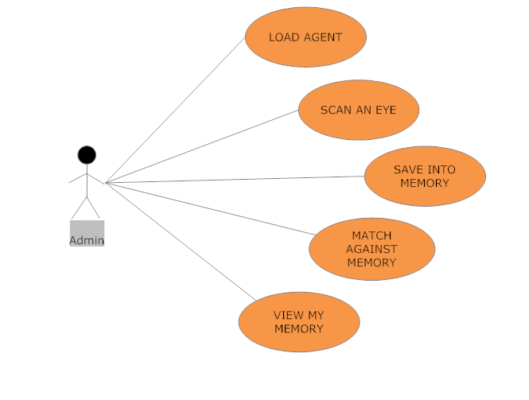
Modules use case diagram

Module 1: Load Agent

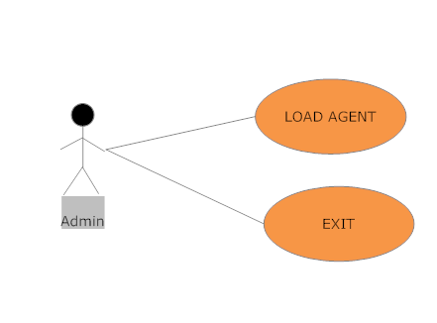

Description : The admin can open File to load the agent files which are already in memory
Data : agent format files from the existing users stored in the memory
Action : The action is to select the existing users known as agent files which are stored
in the memory and then to exit from the iris system

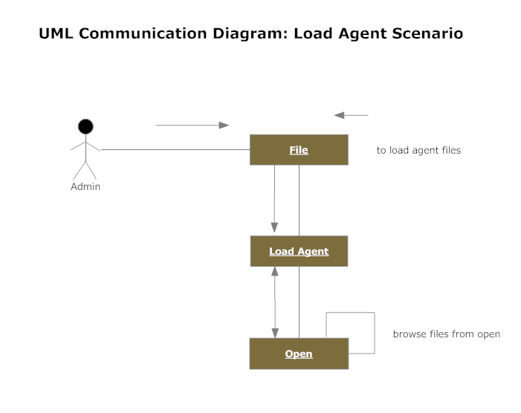

Admin can load the agent file just by browsing the files from the memory where the known identities are saved as a “.agt” files

Sample screenshot:

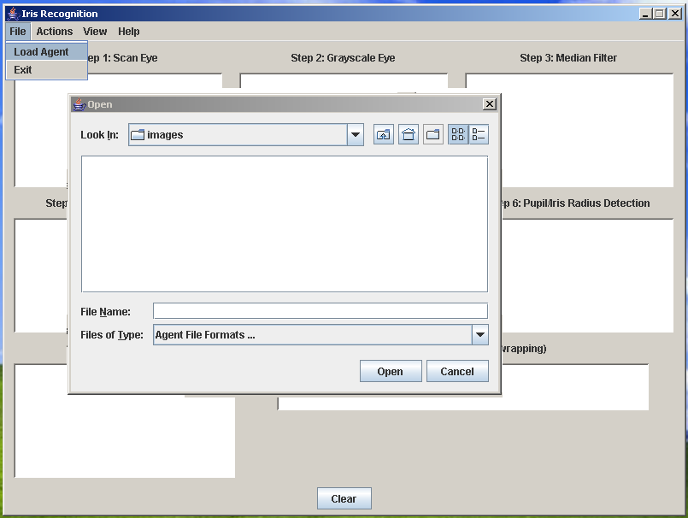

Module 2: Scan an Eye

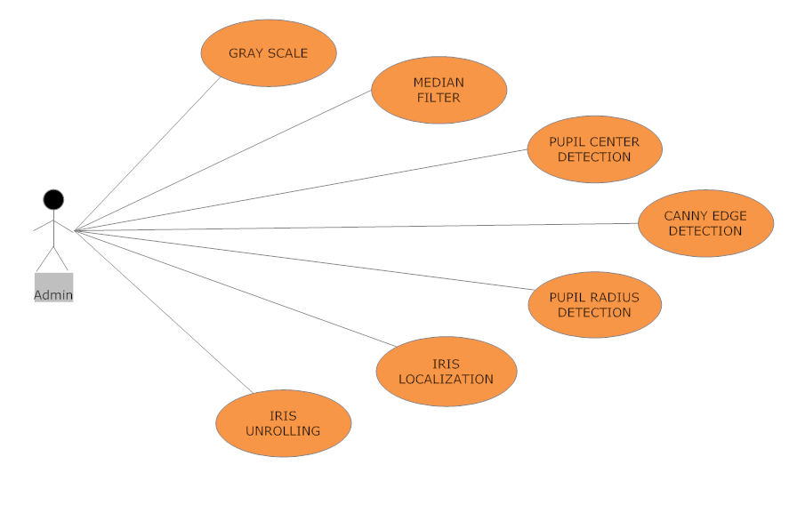

Description : The admin has to scan the eye from the user and the original eye image should be converted into an unrolled iris code by preprocessing.

Data : Eye image from the user to convert into iris code (polar array)

Action : The action is to convert an eye into iris code which is unrolled polar array
by the above image processing algorithms as given above.

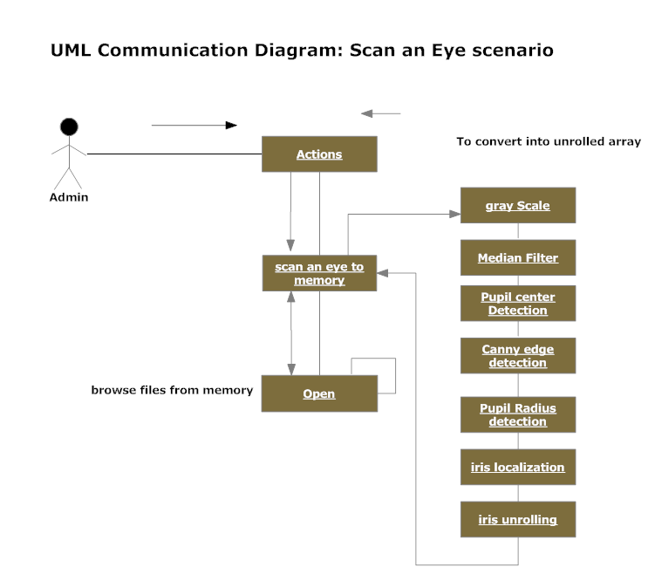

Sample Screenshot:

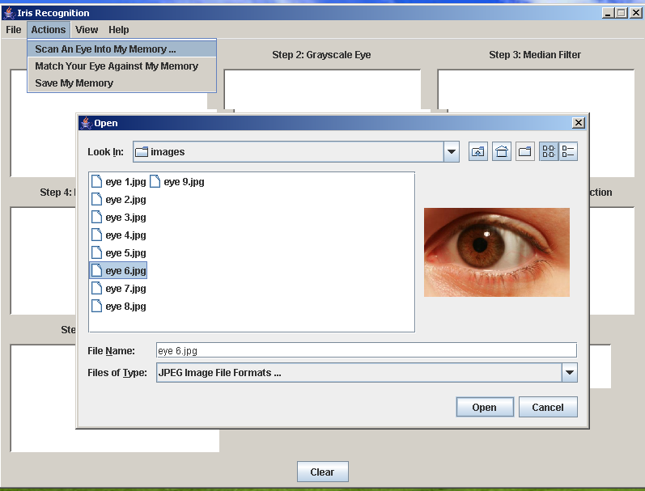

Scanning an eye

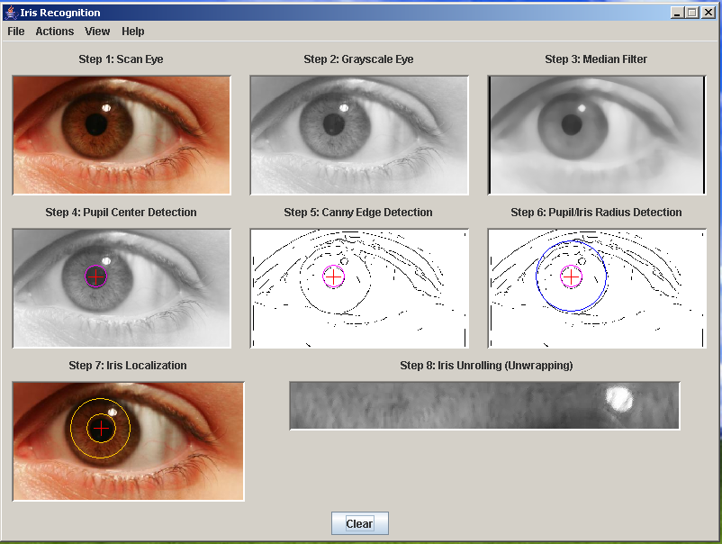

Module 3: save into memory

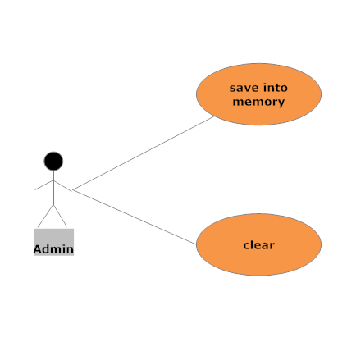

Description : The admin has to save the converted iris code by pre- processing.

Data : iris code from the system which is converted by algorithms [iris code (polar array)]

Action : The action is to save the iris code as Agt file format

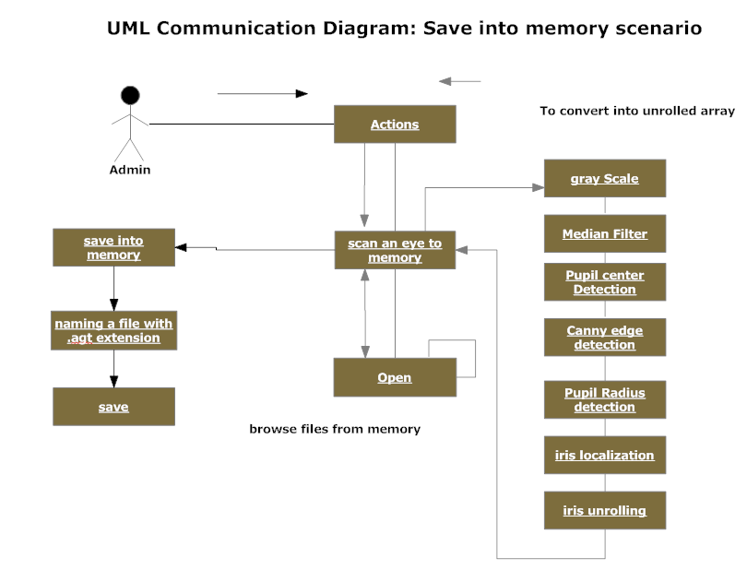

Sample screens:

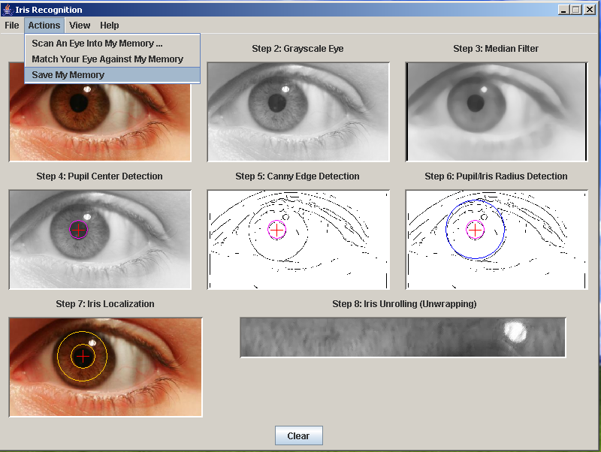

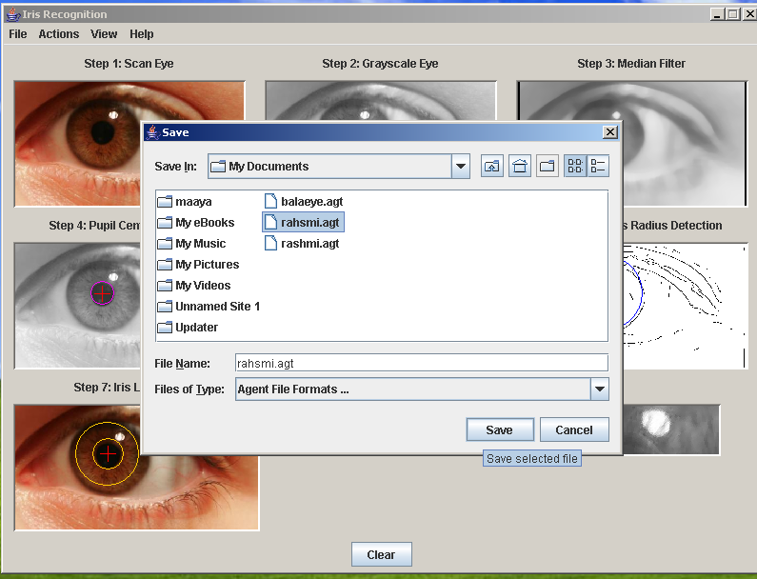

Module 4: Match against my memory:

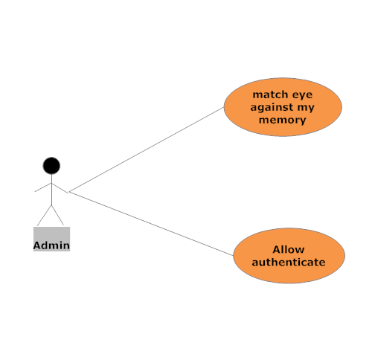

Description : The admin has match the new eye from the user’s eye and the image which is converted and saved as a agt file in system.

Data : Eye image from the user & the converted iris code (polar array)

Action : matching the eye against the memory having agt files.

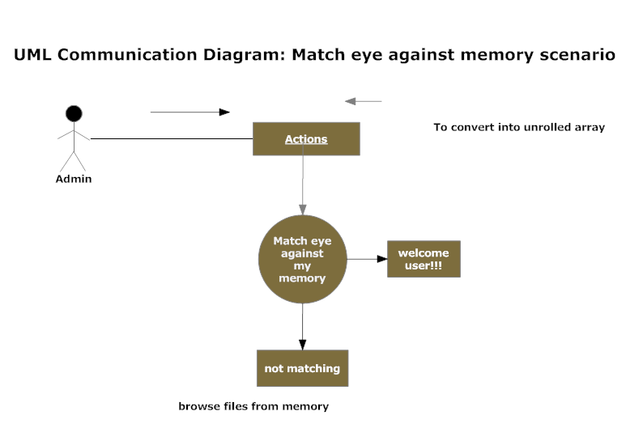

Sample screenshots:

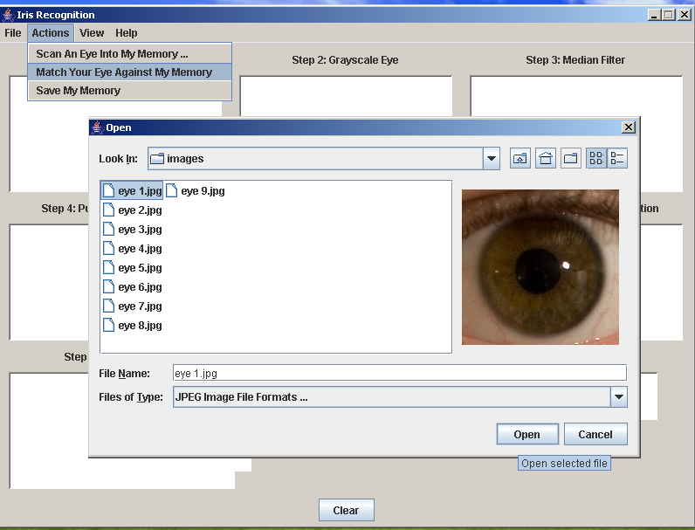

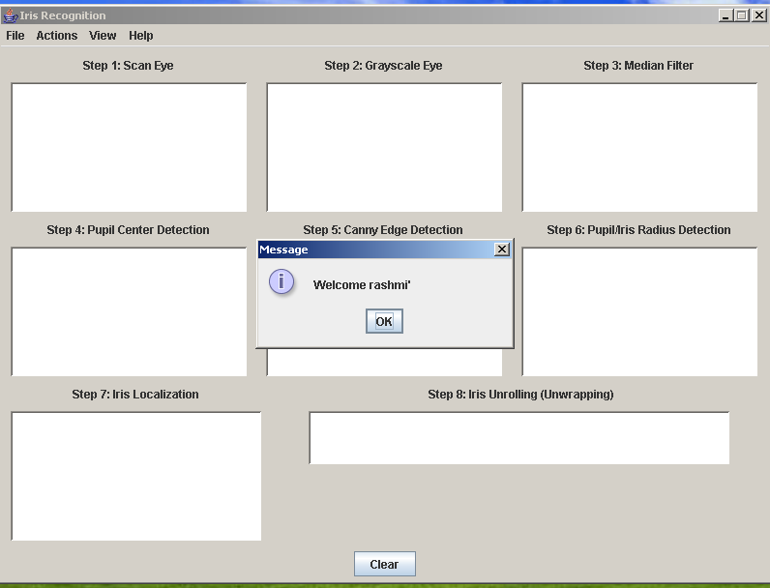

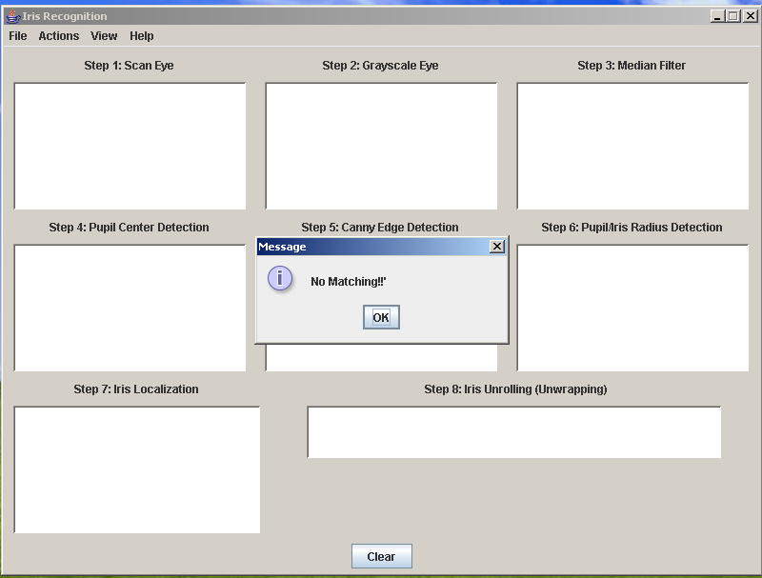

Module 5: view my memory

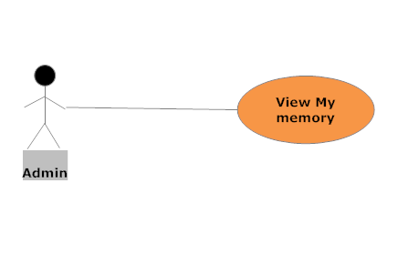

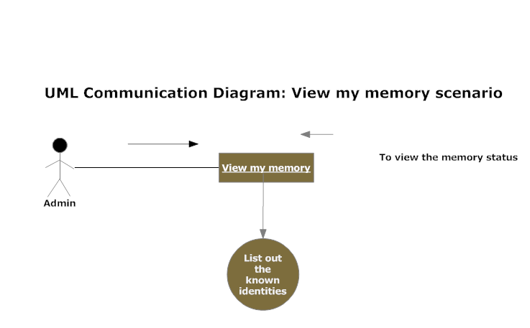

Sample screen

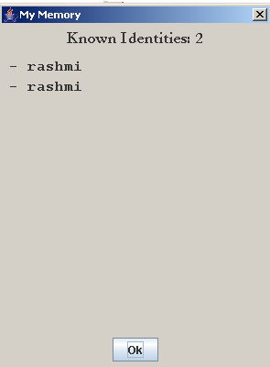

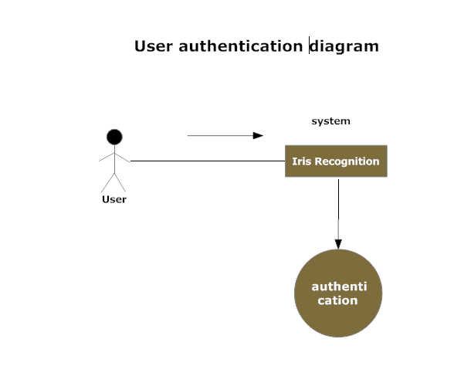
Conclusion:

The primary focus of this work is a personal authentication system based on human iris verification using wavelet packets decomposition. The proposed technique uses only appropriate packets with dominant energies to encode iris texture according the adapted thresholds. The usefulness of this approach was confirmed in the experiments conducted here, which reveals that the verification results with an EER=0.3% has been obtained for packets combination, which means that our system is appropriate for very high security environments.

Bibliography

[1] Ales Muron and Jaroslav Pospisil, “The human iris structure and its usages,” Acta Univ. Palacki. Olomuc. Fac.Rerum Nat. Phys., vol. 39, 2000, pp. 87–95.

[2] J.G. Daugman, “High confidence visual recognition of persons by a test of statistical independence,” IEEE Trans. on Pattern Analysis and Machine Intelligence, vol. 15, no. 11, Nov 1993, pp. 1148–1160.

[3] J.G. Daugman, “Demodulation by Complex-Valued Wavelets for Stochastic Pattern Recognition,” Int’l J.Wavelets, Multiresolution and Information Processing, vol. 1, no. 1, 2003, pp. 1-17.

[4] R. Wildes, J. Asmuth, G. Green, S. Hsu, R. Kolczynski,J. Matey, and S. McBride, “A Machine-Vision System for Iris Recognition,” Machine Vision and Applications, vol. 9, 1996, pp. 1-8.

[5] H. Proenc and L. A. Alexandre, “Toward Noncooperative Iris Recognition:
A Classification Approach Using Multiple Signatures”, IEEE Trans.
on Pattern Analysis and Machine Intelligence, vol. 29, no. 4, Nov 2007, pp.

[6] Kwanghyuk Bae, Seungin Noh, and Jaihei Kim, “Iris feature extraction
using independent component analysis,” Proc. 4th Intl. Conf. on Audio and
Video Based Biometric Person Authentication LNCS, vol. 2688, 2003, pp.

[7] C. Sanchez-Avilaa, R. Sanchez-Reillob, “Two different approaches for iris
recognition using Gabor filters and multiscale zero-crossing representation,”
Pattern Recognition, vol. 38, 2005, pp. 231 – 240.

